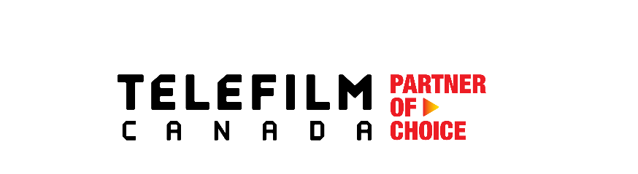
Visibility Grid for Activities
Promotion Program – Limited Edition promotion

Activity name: | Click or tap here to enter text. | Activity date: | Click or tap here to enter text.
Applicant name: | Click or tap here to enter text. | Current date: | Click or tap here to enter text.

The visibility elements below are provided as examples. If any of these elements can't be offered or are not suitable for your activity, please contact your regional project manager to discuss and suggest alternatives.

TELEFILM LOGO AND MENTIONS - In all formal and external communications (verbal, written, electronic or other), with logo size and placement reflecting Telefilm’s relative rank among financial partners.

REQUIRED VISIBILITY ELEMENTS | VISIBILITY PROVIDED?  (yes/no) | DETAILS (placement, quantities, examples, etc.) – include screenshots when possible**  To be completed after activity is held
Logo on posters | Choose an item. | Click or tap here to enter text.
Logo on website (with link to Telefilm website) | Choose an item. | Click or tap here to enter text.
Logo on catalogue/program/invitations | Choose an item. | Click or tap here to enter text.
Logo on media releases | Choose an item. | Click or tap here to enter text.
Telefilm message in catalogue/program/website | Choose an item. | Click or tap here to enter text.
Ad in catalogue/program | Choose an item. | Click or tap here to enter text.
Telefilm speaking opportunities (media event, reception, event, etc.) | Choose an item. | Click or tap here to enter text.
Mention of Telefilm support at media event, reception, event | Choose an item. | Click or tap here to enter text.
Mention of Telefilm support on social media | Choose an item. | Click or tap here to enter text.
Web ad/banner | Choose an item. | Click or tap here to enter text.
Trailer  (shown at opening/closing ceremonies, beginning of screenings and other relevant events, workshops or panels) | Choose an item. | Click or tap here to enter text.
Pop up banner | Choose an item. | Click or tap here to enter text.
Access to key events/online screenings  Tickets or passes to be negotiated with Telefilm prior to event | Choose an item. | Click or tap here to enter text.
ADDITIONAL VISIBILITY ELEMENTS  If Telefilm support is > or = $25,000* | VISIBILITY PROVIDED?  (yes/no) | DETAILS (placement, quantities, examples, etc.) – include screenshots when possible**  To be completed after activity is held
Targeted visibility opportunities  Propose visibility opportunities aligned with Telefilm’s objectives (e.g., Canadian screen‐based content and talent promotion). | Choose an item. | Click or tap here to enter text.
Mention of Telefilm support in media interviews | Choose an item. | Click or tap here to enter text.
Opportunity to provide quote for media releases | Choose an item. | Click or tap here to enter text.
IMPACT– What impact did the funding provided by Telefilm have on your activity? (Describe in 2-3 lines)
Click or tap here to enter text.

NOTE: The content and design of all communications materials are subject to prior approval by Telefilm.
* Telefilm reserves the right to require this visibility element when Telefilm’s support is less than $25,000
** Screenshots to be provided as a separate attachment

